**Warehouse Product Classification: Utilizing K-Means Clustering**

**Introduction**

In the dynamic landscape of warehouse management, efficient product classification is crucial for optimizing storage, handling, and distribution. This report outlines the process of classifying warehouse products using K-Means clustering, a powerful machine learning algorithm. The objective is to group products based on their order count and average weight, thereby facilitating better organization and inventory management.

**Data Overview**

The dataset used in this analysis comprises various attributes of warehouse products, including:

* Sum of count of orders
* Average product weight in Kg
* Product Family (for reference and interpretation)

**Methodology**

### **Data Standardization**

To ensure that the features used for clustering are on a comparable scale, the data was standardized. Standardization transforms the data to have a mean of 0 and a standard deviation of 1. This process is critical for the K-Means algorithm, which relies on Euclidean distance for clustering.

### **Determining the Number of Clusters**

The optimal number of clusters was determined using the Elbow Method. This method involves plotting the Within-Cluster Sum of Square (WCSS) against the number of clusters and identifying the "elbow point" where the rate of decrease sharply changes.

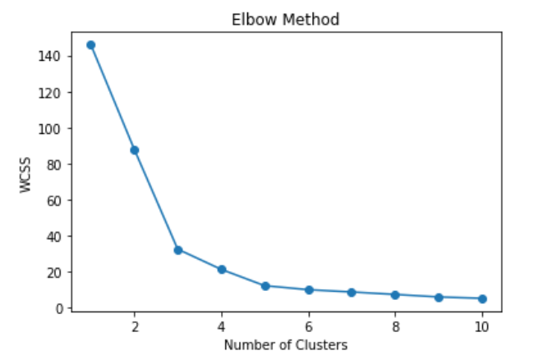

### **Inferences:**

Based on the elbow plot, three clusters were chosen for the final model.

### **Applying K-Means Clustering**

With the number of clusters determined, the K-Means algorithm was applied to the standardized data. Each product was assigned to one of the three clusters.

**Results and Interpretation**

The clustering results were visualized using a scatter plot, with the clusters distinguished by different colours. The plot illustrates how the products are grouped based on the sum of orders and average weight.

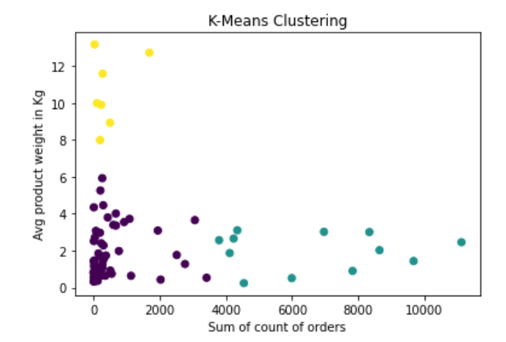

**Conclusion**

The application of K-Means clustering to warehouse product data enables effective categorization based on key attributes. This classification aids in better understanding product characteristics, optimizing storage solutions, and enhancing inventory management. The clusters reveal patterns that can inform strategic decisions in warehouse operations, ultimately leading to improved efficiency and cost savings.

By leveraging machine learning techniques like K-Means clustering, warehouses can achieve a higher level of organization and responsiveness to market demands, ensuring products are stored and managed in the most efficient manner possible.